# **Test Plan - Mr Buggy6**

## Introduction - analysis

This document presents a test plan for the Mr Buggy6. The purpose it is to present a taken strategy for testing process.

Application MrBuggy6 is a tool for managers of the company providing testing services. This piece of software should allow Managers to keep a track of bidding process for new testing projects (called opportunities), maintain current testing projects (called projects), with access to the list of human resources (employees), clients and services provided by the company. This is the first version delivered by developers to tests so it is expected to contains some defects.

## Test strategy

### 2.1 Scope of testing

### In scope:

* Functional testing - main functionalities in dashboard (include modules: projects, employees, clients, services and opportunities), profile and logout.
* The application will be completely tested by only one person.
* Testing should last no more than 5 days.

Areas to be tested:

Functionality - test activities set by priority:

**HIGH:**

1. Test user’s password set up
2. Test the login and logout process from the system
3. Check edition of the “Profile” form
4. Check "New" and "Edit" functions on employee's tab
5. Verify validation for adding and editing clients records in the system
6. Verify validation for adding and editing services records in the system
7. Test the project's tab (assignment of the employee to a service and a client) including an export function
8. Use CRUD heuristic to test "Opportunities"
9. Verify correctness of the data in "Dashboard" table
10. Test the search options where available in the system
11. Test the filter options where available in the system.

**LOW (if testing is completed before the scheduled time):**

1. Skills located on ‘Employees’ tab.
2. ‘Send a message to admin’ function (‘envelope’ icon located on the right on the page),
3. Reset data function,
4. Minimize, maximize and close buttons.

Device needed for testing:

* Any PC/ Laptop

### 2.2 Out of scope:

* nonfunctional testing such as stress, performance or logical database currently,
* usability issues,
* all data are in text format and are not validated.

## 2.3 Testing type

The application will be tested for functional tests, based on the analysis of the specifications of the entire system.

## 2.4 Risk & Issues

Risk: Not enough time to test the application.

Migration:Focus on the most important components to test (priority setting is contained on that document).

## 2.5 Test logistic

The planned test process is included:

- planning and analysis,

- test design,

- test execution,

- presenting the results in the final report.

The tests will use combined approaches - based on checklist analytical, such as test-cases testing.

## Test objective

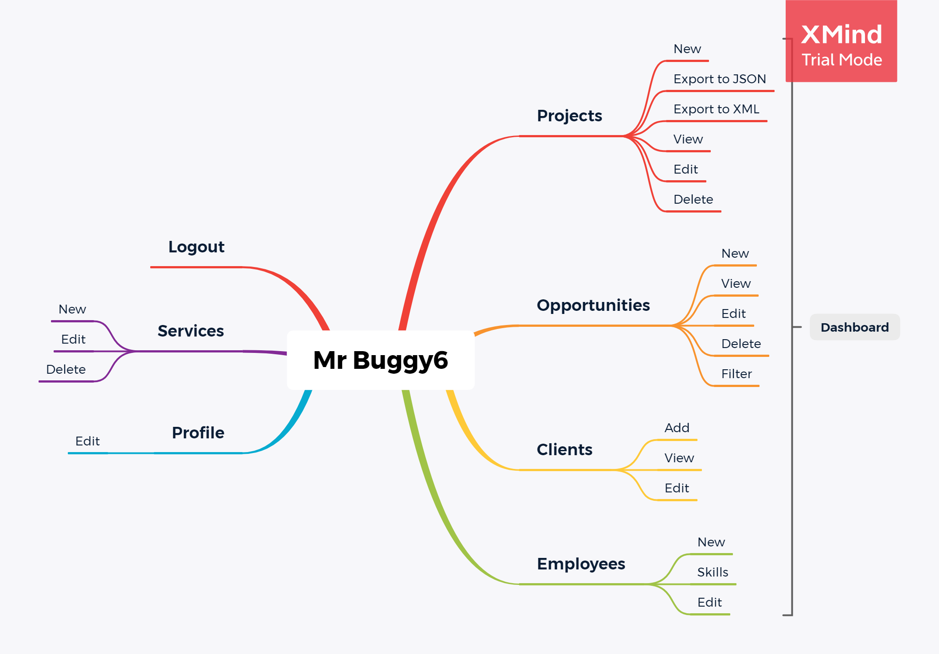

## Test criteria

### Entry criteria:

- readiness test environment is available,

- test tool is readiness in the test environment,

- available code is testable,

- available test data,

- one trained employee.

## Resource planning

### Exit criteria:

- mesure:

Run rate should be at least 90% test coverage test.

-estimates:

The best case estimate:

- the tester will create more than 50 test cases during 5 days,

- the tester will test functionalities from low priority areas (look at scope of testing),

- the tester will create a at least 5 test cases, test report contained at least 10 defects, a detailed RTM Matrix, containing all test cases divided into individual categories in the system and the test report.

The most likely estimate:

- the tester will create at least 50 test cases in 5 days

- the tester will not have time to test functionalities from low priority areas (look at scope of testing),

- the tester will create a at least 5 test cases, test report contained at least 7 defects and a detailed RTM Matrix, containing the most important test cases (modules with the highest number of reported defects) ant the test report.

The worst case estimate:

- the tester will not create even 20 test cases in 5 days,

- the tester will not have time to test functionalities from low priority areas (look at scope of testing),

- the tester will create a at least 5 test cases, test report contained at least 5 defects and the test report,

- the tester will leave the company during the tests performed.

- cost (only free time ;))

### 5.1 Human Resource

1. Dziedziuch as a:

* test manager: prepare a test plan,
* tester: prepare test cases, defects report and test report.

### 5.2 System Resource

* Server should be installed the desktop application under the test;
* Computer / Laptop - the PC which user use to connect with application and database.

## Schedule and estimation

1. Preparing test plan - 1 day
2. Creating the test specification and test cases - 1 day
3. Performing test execution - 1 day
4. Preparing defects report - 1 day
5. Preparing test report - 1 day

# TOTAL: 5 days

## 7. Test deliverables

Test deliverables are provided before testing:

* Test Plan,
* Test Cases (5)

Test deliverables are provided during the testing:

* Test Traceability Matrix,

Test deliverables are provided after the testing:

* Defect Report (10)
* Defect attachments (screenshots).